ACTIVITY DIAGRAMS (Customer)
- Authentication (Register + Login)
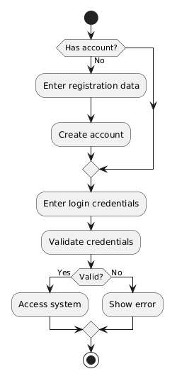
- Search Routes & View Schedules
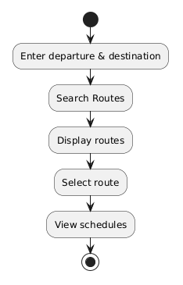

- Purchase Ticket
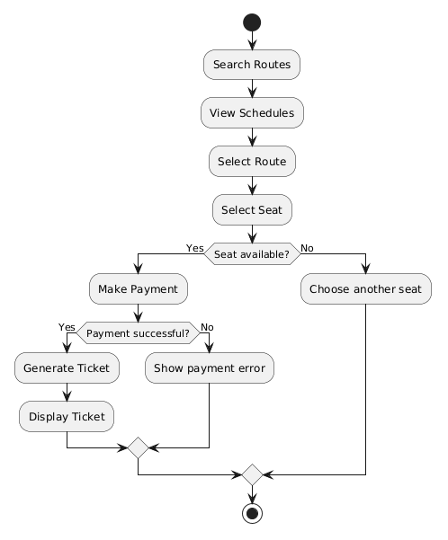
/////////////////////////////////////////////////////////////////////////////////////////////////////
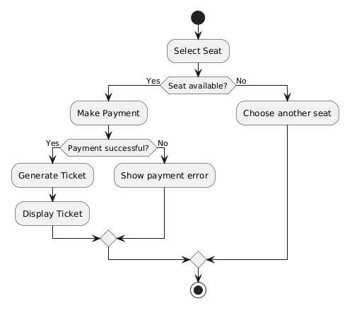

- Manage Profile
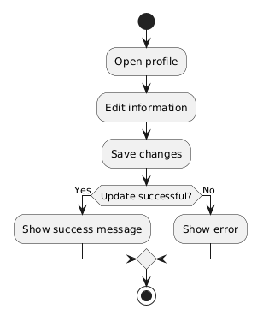

SEQUENCE DIAGRAMS (Customer)

1. Authentication
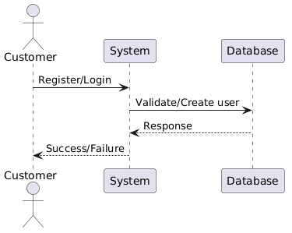

2. Search Routes & View Schedules
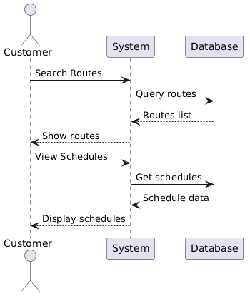

3. Purchase Ticket
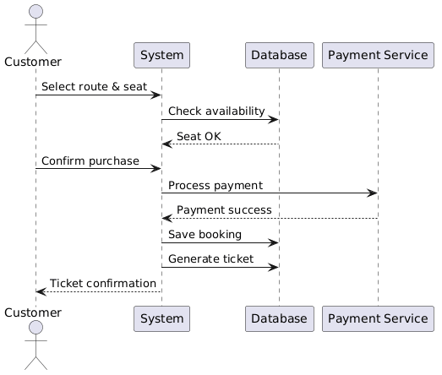

4.Manage Profile
